How to Set Up & Publish a Package Using UV on PyPI + Virtual Env Notes + YT Setup Wizard Video’s Link!

The Working Way - Video: Publish Your Own Python Package in Less Than 10 Minutes
Summary:
Let UV handle the package structure for you. For example, me & many developers didn’t initially know that a src folder is required. This folder will contain your package files.

1. Initialize the Package
Command: uv init --package <package-name>
This creates a folder with the package name. Inside, you'll find:
- pyproject.toml file
- README.md
- .python-version
- src/ folder (place your original package/module files here)

Delete the content inside __init__.py and replace it with the exposure of your modules/functions using the __all__ list.

**Important Note:**: Delete all previously created __pycache__ files in your original package before moving it into src/, as they might cause issues.
**Important Note:** Move inside the package's directory. Do not work from the root if you are about to build and publish.

2. Edit the pyproject.toml File
- Add dependencies (if you did not use UV instead of pip from the start).
- Add your documentation and repository links under [project.links].
- Remove the main script from the pyproject.toml file if not needed.
- Generate the README for the PyPI page.

The README should contain:
- Description: At the very top, with a preview.
- Detailed package information for the PyPI page.
- Properly listed dependencies to allow for correct downloads.
- [project.urls]: Links to Home, Repo, and Documentation (later).

**Extra Note:** To generate an old-style requirements.txt file, run:
uv pip install -r requirements.txt

3. Build the Package Locally (within the package’s directory)
Command: uv build --no-sources
- Creates the dist folder with .whl and .tar files.
- Sometimes, you may find the dist folder on the desktop. If so, move it into the root folder inside the package manually.

The --no-sources flag tells UV to build only binary distributions (like wheels) and exclude source distributions (like .tar.gz). This is common for simple pure-Python packages or when you want to avoid distributing source code.

4. Publish on TestPyPI
Command:
uv publish --token pypi-<your-api-key> --publish-url https://test.pypi.org/legacy/

**Extra:** Summary of Required Steps to Publish a New Version:
- Bump the version in pyproject.toml.
- Build with uv build --no-sources.
- Publish with uv publish --token ... --publish-url https://test.pypi.org/legacy/.

Note:
After updating your package version in pyproject.toml, always delete old build files from the dist/ directory before rebuilding and publishing. This ensures you upload the correct, latest version to PyPI or TestPyPI.

Note - Steps:
1. Delete all files in dist/ (e.g., attendance_tooltt-0.1.0*).
2. Run uv build --no-sources to create new build files.
3. Publish the new version with uv publish --token <your-api-key> --publish-url https://test.pypi.org/legacy/.

This prevents version conflicts and upload errors!
Additional Information:
- The src folder is a common convention to separate source code from other files.
- Inside src, your actual package is attendance_tool_msp, which contains your Python modules and (optionally) assets for GUI.
- Your build and configuration files are in attendance_tool_msp (used for the package name, installable through pip, dependencies, etc.).
- Your actual Python package is in src/attendance_tool_msp, and this will be the part downloaded by the user.

5. Publish On PyPi
Command: uv publish --token pypi-<your-api-key>
Only Publish On PyPi when you’re 100% satisfied through testing on TestPyPi.

Virtual Environments
A virtual environment in Python is an isolated workspace for your project. It lets you install packages just for that project, without affecting other Python projects or your global Python installation!
To create a virtual environment, run:
python -m venv .venv
To activate it in Command Prompt, run:
.venv\Scripts\Activate
- Which is literally a script inside .venv in your folder!
In Visual Studio Code, you can see your current Python environment at the bottom right.
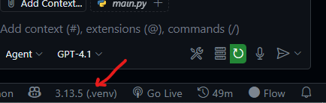
This is the environment VS Code uses to run your code. If a package is missing in your environment, you’ll see an error (red underline or yellow underline).
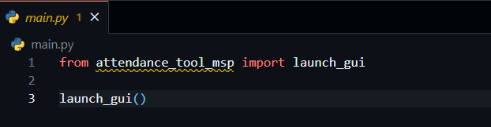
The terminal and VS Code may use different environments, so make sure you’re working in the correct one. Select the same environment for both the terminal & VS Code! (Consistency)
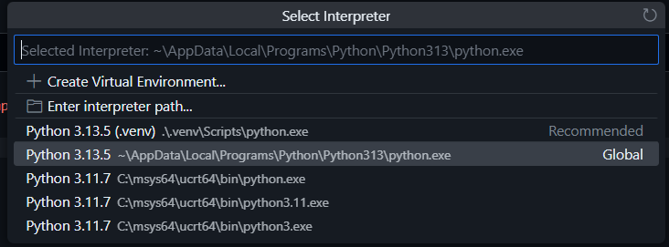
Don’t worry if things look complicated- just activate your venv and install packages as needed for your project.

Setup Wizard Video: Convert GUI App to Real Program - Python to exe to setup wizard

